Design: database

Compatibility and availability were two important factors that played a role in selecting the database. Compatibility is important because the database and other technologies that are going to be used need to be compatible and work well together, in this case the technologies that are going to be used are Django Framework and Python. Availability is important because the project is going to be hosted in the cloud and the cloud provider needs to be offering the database as one its services and in this case the cloud provider is AWS. Also another deciding factor that played a role in selecting the database is the type of data that is going to be stored and inventory data is relational. Using a relational database is also important because if the project were to be implemented in real world the database would need to have multiple tables such as a table containing information about inventory suppliers.

MySQL is a relational database and that is what is needed for the project. The database will have only one table that will contain part inventory information such as part number, part description, different locations where the inventory is located and quantities at the locations. Part number is a unique number that is assigned to only one part and will be the primary key, the rest of the columns can overlap and the information is not unique in a sense that part numbers can have similar description if not the same, be located at the same location and have same quantities either at the location or in the system (another database).

**Column types**

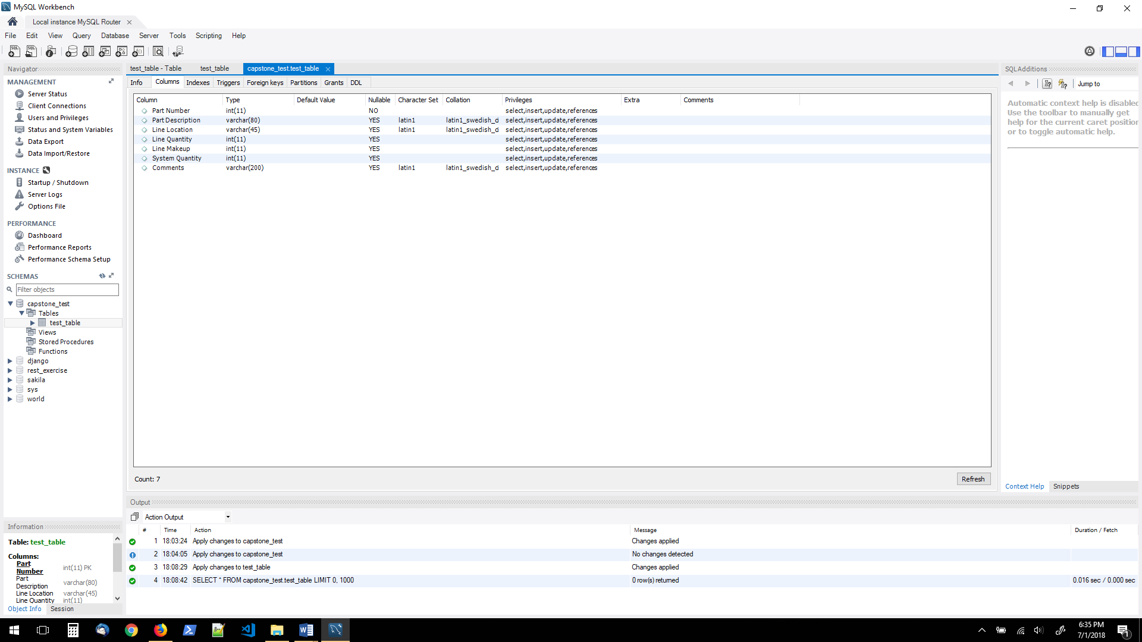

**Entity-relationship diagram**

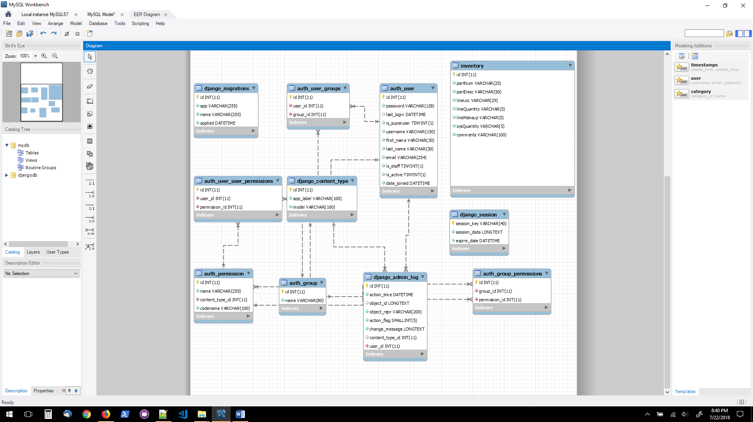

**Inventory table** – the main table that is necessary to perform the CRUD operation, the purpose of the table is to save all the data that user saves and allow the user to retrieve and make changes to information. Inventory table is one of the more important components of the project and therefore it is considered to be part of MVP because without it the user would not be able to perform the CRUD operation.

All other tables are created by Django and the tables are not necessary for my purposes, however in production environment the tables would be necessary for application management, such as managing different user groups and their access privileges. All of the other tables created by Django are part of stretch features and they would all be needed if the application were to be expanded and more features were added such as enabling user registration and login.